<<20131105>> Archived distributions can be retrieved at; <http://tinyurl.com/azg3eyl>. This archive includes a html version of this list distribution and its MS/WORD version with its filename as “year-month-date.doc.” You can also access all of its attachments, if any.
P. Tapio Varis, Ph.D., Professor <tapio.varis@uta.fi>
Chris Uwaje (Fncs, Fiap) <Admin@ispon.org>
References:
(a) (20131027) Tapio's presentation at the National Software Conference 2013 at Tinapa, Nigeria on 22-23 October <http://tinyurl.com/kze4nps>
(b) Global Peace Through The Global University System
Tapio Varis - Takeshi Utsumi - William Klemm (Eds.)
University of Tampere, Finland 2003
ISBN 951-44-5695-5
The entire contents of this book can be retrieved at;
<http://tinyurl.com/kofpf>
In the bottom line of this page, you can find the following;
(c) “Interview with Takeshi Utsumi” by Parker Rossman
<http://tinyurl.com/fnxxt>
This book also include the followings;
(d) Takeshi Utsumi, P. Tapio Varis, and W. R. Klemm
"Creating Global University System (GUS)"
<http://tinyurl.com/sfgm7>
(e) Takeshi Utsumi, GLOSAS/USA
"Globally Collaborative Environmental Peace Gaming (GCEPG)" -- the origin of our current GEWS project
<http://tinyurl.com/k2c7a>
Dear Tapio:
(1) Many thanks for your msg (ATTACHMENT I below).
(2) Many thanks for your giving our book (Reference (b) above) to The Executive Governor of Cross River State, Senator Liyel Imoke at the occasion of the National Software Conference 2013 at Tinapa, Nigeria on 22-23 October (Reference (a) above).
Dear Chris:
(3) My wholehearted congratulations to the success of your conference!!
It is my great honor and sincere thanks to receive an award at this occasion (ATTACHMENT II). This is utterly out of my expectation, since I haven’t done any significant contribution to your prestigious Institute of Software Practitioners of Nigeria (ISPON) yet.
Anyway, I shall keep this beautiful plaque as our family treasure. Once again, thank you very much, indeed, for this honor.
Best, Tak

ATTACHMENT I
From: "Tapio Varis" <Tapio.Varis@uta.fi>
Subject: Re: [gu-new] (20131027) Tapio's presentation at the National Software Conference 2013 at Tinapa, Nigeria on 22-23 October
Date: October 28, 2013 at 1:59:21 PM EDT
To: takutsumi0@gmail.com
Dear Tak,
Thank you again. Please find attached a photo of The Executive
Governor of Cross River State, Senator Liyel Imoke receiving our book
on GUS,
<http://tinyurl.com/l74varw>
I also have an Award to you that was given to you in the Conference.
Do you want me to send it to you or bring it when I come to the U.S.
next time?
Best,
Tapio

ATTACHMENT II
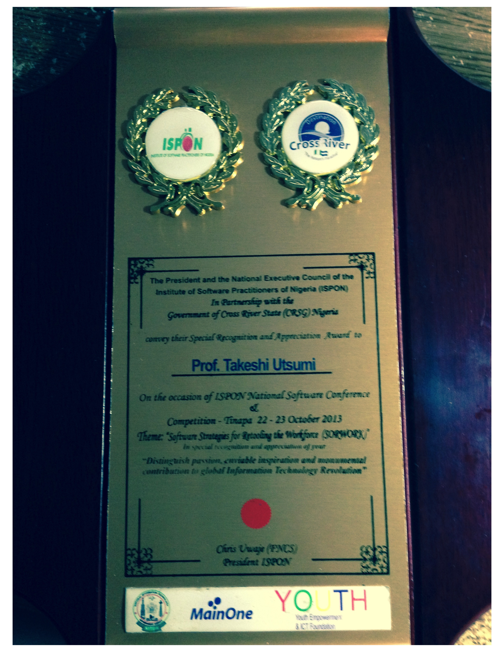
<http://tinyurl.com/md7hmtm>
Top Left Emblem
ISPON
Institute of Software Practitioners of Nigeria
Top Right Emblem
Destination
Cross River
The Nation’s Paradise
The President and the National Executive Council of the
Institute of Software Practitioners of Nigeria (ISPON)
In Partnership with the
Government of Cross River State (CRSG) Nigeria
convey their Special Recognition and Appreciation Award to
Prof. Takeshi Utsumi
On the occasion of ISPON National Software Conference
&
Competition – Tinapa 22 – 23 October 2013
Theme: “Software Strategies for Retooling the Workforce (SORWORK)”
In special recognition and appreciation of your
“Distinguish passion, enviable inspiration and monumental
Contribution to global Information Technology Revolution”
Chris Uwaje (FNCS)
President ISPON
Bottom Left: National Information Technology Development Agency (NITDA)
Bottom Middle: MainOne
Bottom Right: Youth Empowerment & ICT Foundation

List of Distribution
P. Tapio Varis, Ph.D., Professor
Acting President, Global University System
UNESCO Chair in Global e-Learning with applications to multiple domains
Professor and Chair of Media Education
Research Center for Vocational Education & Hypermedia Laboratory
University of Tampere
P.O.Box 229
FIN-13101 Hameenlinna
FINLAND
+358-3-3551-3608
Tel: +358-3-614-5608--office in Hameenlinna
Tel: +358-3-215 6243--mass media lab in Tampere
GSM: +358-50-567-9833
Fax: +358-3-614-5611 or +358-3-3551-3611
tapio.varis@uta.fi
tapio.varis@hamk.fi
tapio.varis@helsinki.fi
http://www.uta.fi/~titava
www.ecml-eu.org -- about ECML project.
http://www.uta.fi/conference/mediaskills/
Chris Uwaje (Fncs, Fiap)
Chief Executive Officer
Connect Technologies Limited
President
15B Awolowo Road, SW Ikoyi
Lagos, NIGERIA
or
President
Institute of Software Practitioners of Nigeria (ISPON)
InfoGraphics Nigeria
8, Oduduwa Way
GRA Ikeja
Lagos, Nigeria
Tel: 234-1-794-2050, 803-300-5005
Cel: +234-813-228-2426
Admin@ispon.org
info@ispon.org

*******************************************************************************
Takeshi Utsumi, Ph.D., P.E., Chairman
GLObal Systems Analysis and Simulation Association in the U.S.A. (GLOSAS/USA)
Laureate of Lord Perry Award for Excellence in Distance Education
Founder and V.P. for Technology and Coordination of Global University System (GUS)
43-23 Colden Street, #9L, Flushing, NY 11355-5913, U.S.A.
Tel: 718-939-0928; Cel: 646-589-1730; Skype: utsumi
Email: takutsumi0@gmail.com, Web: http://www.friends-partners.org/GLOSAS/
U.S./IRS Employer ID: 11-2999676 <http://tinyurl.com/534gxc>
New York State Tax Exempt ID: 217837 <http://tinyurl.com/47wqbo>
Google Profiles <https://profiles.google.com/takutsumi0/about>
Wikipedia <http://en.wikipedia.org/wiki/Takeshi_Utsumi>
Facebook <http://www.facebook.com/GlobalEarlyWarningSystemsgews>
List Distribution <http://tinyurl.com/2fzx23e>
*******************************************************************************

